International Mining Engineering Consultants |  | MEDIA RELEASE
  - 28th June 2016
  - COMPANY ANNOUCEMENT
  - Successful Completion of Underground Dewatering System Project

KEY POINTS
- High Flow & Head Underground Dewatering System of high temperature groundwater.
- IME Consultants engaged for engineering, procurement & onsite construction support & commissioning.
- System installed to pump high temperature water collected from underground borehole dewatering pumps and discharge direct to surface treatment system.
- Inclusions for future expansion of the system along with sustaining initiatives.

IME Consultants (IMEC) is pleased to announce the successful completion and commissioning of a Primary Underground Pumping System for an underground Gold Mine in Indonesia. The project formed part of a site wide plan to dewater the orebody ahead of mining advance through the use of deep borehole pumping from various underground mining horizons into a central Primary Pump Station that could pump water direct to surface.
The pump station was strategically located in proximity to the bore field to enable direct discharge of bore dewatering into the primary system with delivery of the water then direct to surface via a dedicated and purpose installed Rising Main pipeline.
The underground mine geology encounters a deep hydrothermal groundwater system causing inflow of high temperature water (up to 85⁰C) in to the underground workings. The reliable and efficient dewatering of these thermal waters is intrinsic to the ongoing exploitation of ore reserves and more overtly the safety and wellbeing of underground personnel, hence IMEC were engaged to engineer and support with procurement and construction activities for establishing a system that was fit for purpose to accommodate the unique duty.
To ensure a maintained lowered water table, a system discharge rate of 400 litres per second (l/s) was nominated, which resulted in a pumping total dynamic head (TDH) of over 200m. The duty and also the water temperature limited the options for standard market equipment and therefore required the engagement of industry leading suppliers to offer highly specified equipment.
The water being delivered to the pumping system had very low solids concentrations and so the use of multi-stage centrifugal pumps was selected. Leaders in the provision of underground pumping equipment ‘Challenge Pumps’ based in Australia, were selected by IMEC to develop and construct pumpsets that could achieve the duty in not only an efficient manner but also reliably.
Through fluid mechanical flow modelling, IMEC in close consultation with Challenge Pumps, selected suitable pumpsets that would be close coupled to 600kW 4 pole motors in a ‘duty/stand-by’ arrangement or in emergency scenarios ‘duty/duty’ to achieve the target duty.
IMEC developed a system operating function in close consultation with the site stakeholders to ensure a maintenance friendly solution was established and incorporated learnings from the sites technical teams who have proven experience working with pump systems in the mine.
A sophisticated Control Enclosure was constructed and supplied by Perth based company ‘Murray Engineering’ that housed the system PLC, starters, and electrical switchgear all in a temperature controlled environment.
The system was pre-commissioned offsite and the nature of the design enabled a quick and effective installation onsite which was important given the hot underground working conditions and also remote location which would make rapidly mobilising spare equipment difficult.
The system was successfully commissioned in April 2016, without incident and in accordance with the client’s expectations and requirements.
The success of the project demonstrates IMEC’s proven ability to provide their clients with turnkey support and solutions for underground dewatering systems even in the most extreme conditions.
IMEC managed the project in accordance with the client’s standard procedures and practices along with its own Quality Management System that has been certified in accordance with ISO9001.
The successful completion of this project marks a significant achievement for the IMEC team who look forward to continuing to work with their client on ongoing maintenance and expansions of the system.
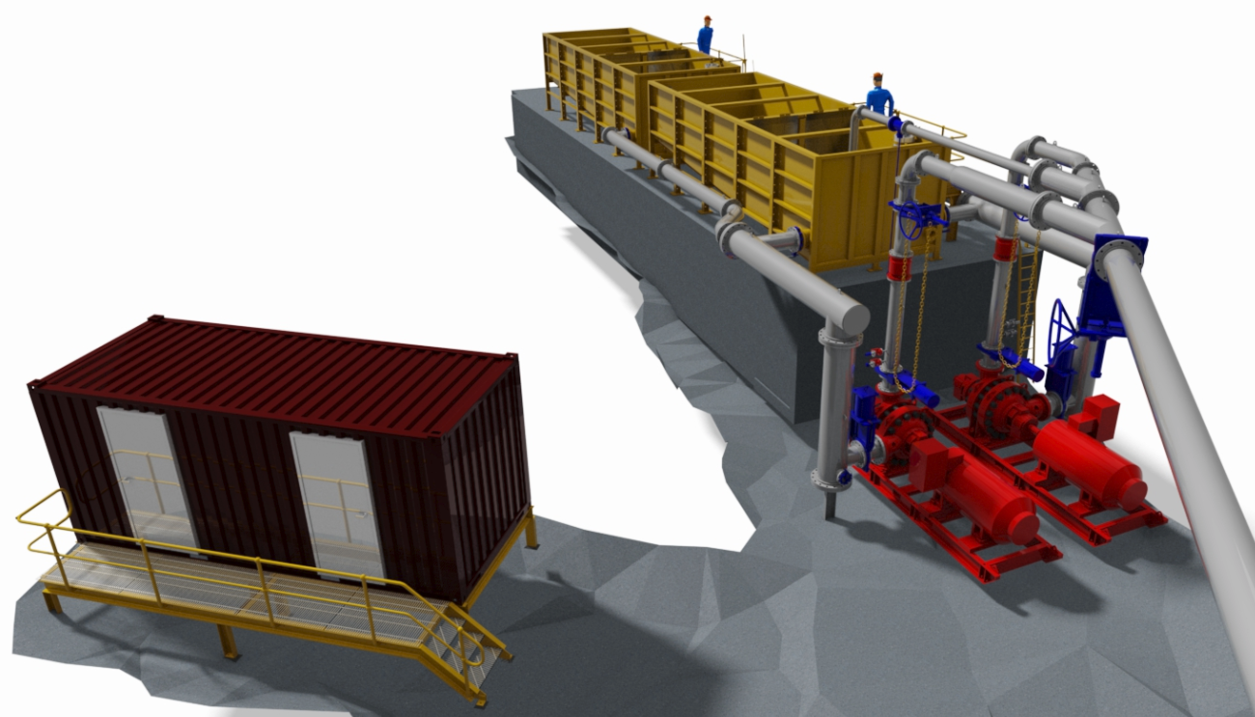
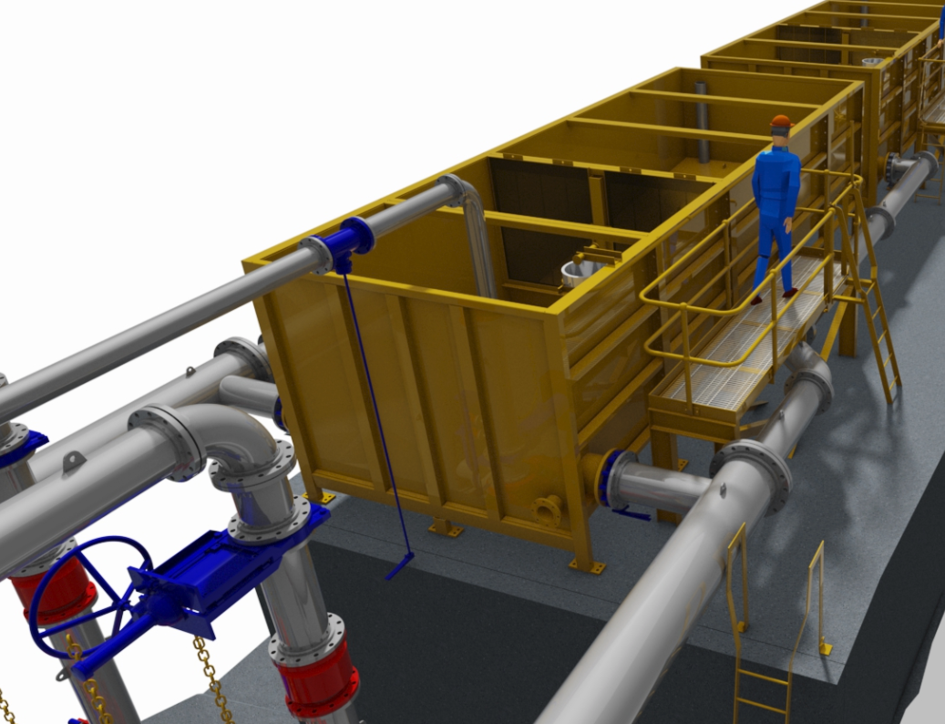
Design Images
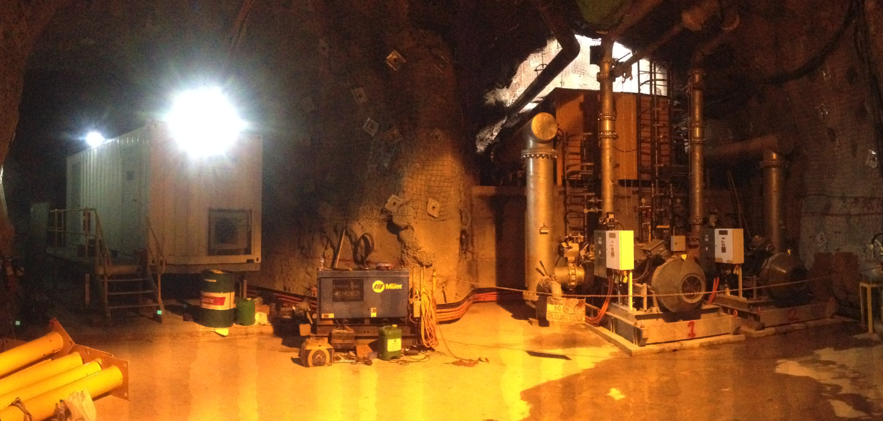
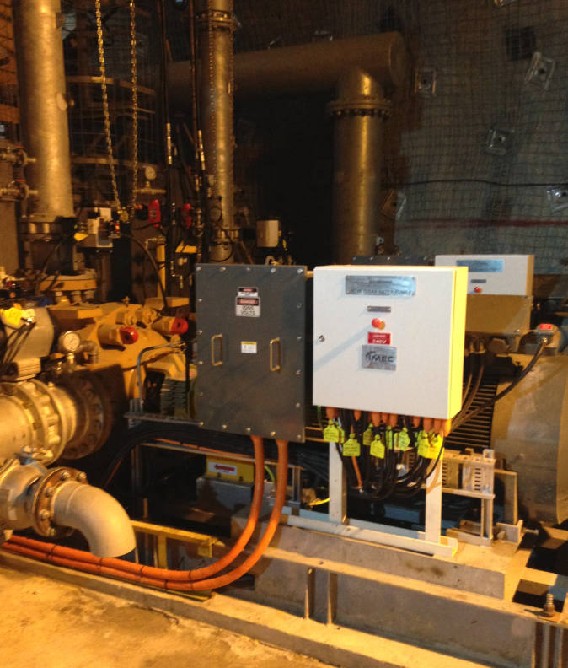
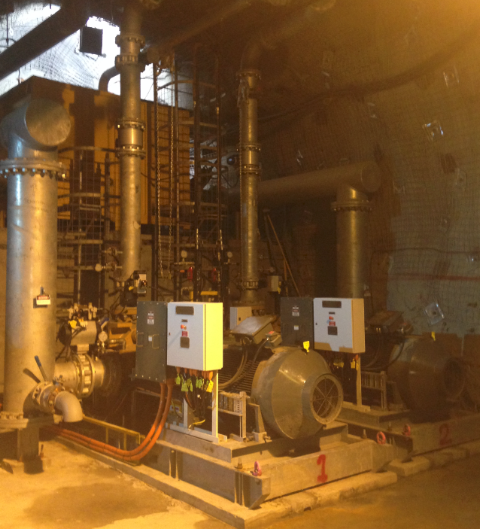

Media enquiries
Derek Jackson
External Relations
Perth Office :+61 8 6102 4632
Mobile : +61 406 295 768
Email : derek.jackson@imeconsultants.com.au

